Software Requirements Specification

for

Graduation Project Management System For IKU

**Version 1.0**

**Prepared by**

**Group Name: <*Group 4*>**

|  |  |  |
| --- | --- | --- |
| **Gökberk Gökçayoğlu** | **1900003468** | **1900003468@stu.iku.edu.tr** |
| **Mert Ulaş Altınsoy** | **1900005461** | **1900005461@stu.iku.edu.tr** |
| **Alihan Kuru** | **1800002457** | **1800002457@stu.iku.edu.tr** |
| **Efe Ayaztepe** | **1800004193** | **1800004193@stu.iku.edu.tr** |
| **Ahmet Kaan Memioğlu**  **Utku Yazıcı**  **Şükrü Erim Sinal**  **Emrecan Üzüm** | **1900005528**  **1900002080**  **1900003587**  **1900005485** | **1900005528@stu.iku.edu.tr**  **1900002080@stu.iku.edu.tr**  **1900003587@stu.iku.edu.tr**  **1900005485@stu.iku.edu.tr** |

|  |  |
| --- | --- |
| **Instructor:** | **<*Akhan Akbulut>*** |
| **Course:** | **<Software Engineering>** |
| **Lab Section:** | ***<Section D>*** |
| **Teaching Assistant:** | ***<Büşra Kocaçınar>*** |
| **Date:** | **<24.05.2022>** |

**Contents**

**Contents ii**

**Revisions iii**

**1** **Introduction 1**

1.1 Project Purpose and Scope, and Objectives 1

1.2 Roles and responsibilities 1

1.3 Technical Assumptions and Constraints 1

1.4 Naming Conventions 1

**2** **Requirements 2**

2.1 Functional Requirements 2

2.2 Non Functional Requirements 2

**3** **Other Requirements 3**

**4** **System Architecture and Architectural Design 4**

4.1 Logical View 4

4.2 Deployment View 4

4.3 Use Case View 4

**5** **Design and Implementation 5**

**6** **Other Supporting Information 6**

**7** **References 7**

**Revisions**

| **Version** | **Primary Author(s)** | **Description of Version** | **Date Completed** |
| --- | --- | --- | --- |
| 1.0 | Group 4 | Graduation Project Management System For IKU | 24/05/2022 |

The purpose of the Graduation Management Project System For IKU is that students can see and select their graduation projects, teachers can see which students have chosen what, then approve the projects that appear, and after the approval process, they can review and grade the files sent by the students.

# Introduction

*<TO DO: Please provide a brief introduction to your project and a brief overview of what the reader will find in this section. Also give some Historical detail: past to today usage area, current works in the literature>*

## Project Purpose and Scope, and Objectives

Our purposes and scope are to offer the professors a maintainable and a reliable program for forming a group by students then applying to desired projects that are formed by professors all in one program also this program allows uploading related projects and files into itself, and Professors have a choice to either approve or deny the request that you have applied earlier. If the application

gets approved you can also declare your free time as a jury in the program so that the program can tell you in which timetables you can be a jury of the presentation. After presentations the professors can also give feedback and score the presentations in one go.

## Roles and responsibilities

Efe Ayaztepe – Orion Login , Authorization and Profiles

Gökberk Gökçayoğlu – In the Web Part ( Student Pages Of The Project)

Ahmet Kaan Memioğlu – In the Web Part ( Professor Pages Of The Project)

Alihan Kuru – Database Design and Evaluation Page

Mert Ulaş Altınsoy – Mobile App, Orion Login , Mobile Pages

Utku Yazıcı – Evaluation Pages on Mobile App, Database Design for Mobile App

Şükrü Erim Sinal / Emrecan Üzüm – Calendar Algorithm

## Technical Assumptions and Constraints

*OS = Android, IOS (Mobile App) / Windows Based Platforms*

*• Platform = Mobile App (Mobile, Tablet) / Web (PC)*

*• Database= MSSQL, SQLITE3*

*• Coding Language = Mobile App / Flutter, Dart, Android Studio Web / ASP.NET, C#, JavaScript*

*• User Interface Style Guide = UI Style, Html, CSS, JavaScript, Bootstrap*

*• System Requirements = Android <9.0>(Pie), IOS<13.0>, Windows<8.1 or Above> Size = 250Mb*

## Naming Conventions

*We used mostly Pascal Case and Camel Case in our Project.*

Variable Names --> SnakeCase

Function Names --> CamelCase

Class Names --> SnakeNames

Files Names--> LowerCase

# Requirements

## Functional Requirements

1.Making the login part simultaneously in connection with the Orion site.

2.Saving user passwords into database as encrypted.

3.Algorithm can automatically match students according to teachers free time.

4. Mobile app must be connect to the web server to more effective communication between web app to mobile app and vice versa.

5-A system can be developed where teachers can download and preview Projects from Mobile app.

6-Teachers can add projects, and students can look at the projects added by the teachers and choose the project they want. Afterwards, the student can see the projects he/she has applied for. After students create their groups, they can upload reports on behalf of their groups.

## Non Functional Requirements

### Performance Requirements

Instead of keeping a local database in the mobile app, we can obtain an architecture where we can get more effective and better performance by pulling the data over the cloud with a web server connection.

**Efficiency** - Code efficiency is a broad term used to describe the reliability, speed, and programming methodology used to develop code for an application.

### Safety and Security Requirements

**Open Source** - Site is open source coded anyone can reach codes.

**Privacy** - Site has a privacy everyone can open private account and do their selections privately.

**Routing Safety**-There are security vulnerabilities in the routing part of the mobile app, which can be configured depending on the routing system, which is more secure.

### Software Quality Attributes

**1-Usability**

-The website be designed in a way that students and department heads can use without difficulty.(clear the what controls does in the website)

-Pages aren't fall apart (for example all the forms that the student will fill in for the internship application will be on a single page.)

-Managers are able to find the detailed controls they require.

-Directions be clear.

**2-Understandability**

-Website codes will be clean.

-There will be an explanatory documentation that will cover all the features of the system.

-The system source code will not overwhelm the user with unnecessary information.

-Within the system, the engineer should be able to quickly locate cross-referenced data.

# System Architecture and Architectural Design

*<Architectural design is concerned with understanding how a software system should be organized and designing the overall structure of that system.*

*TODO: Describe the system architecture, how the application interacts with other component. Also provide a short description about software development approach*>

*Ex:*

*The Model View Controller (MVC) design pattern is used….. Parts…..*

*Or*

*N-tier architecture is used…..*

## Logical View

***CLASS DIAGRAM***

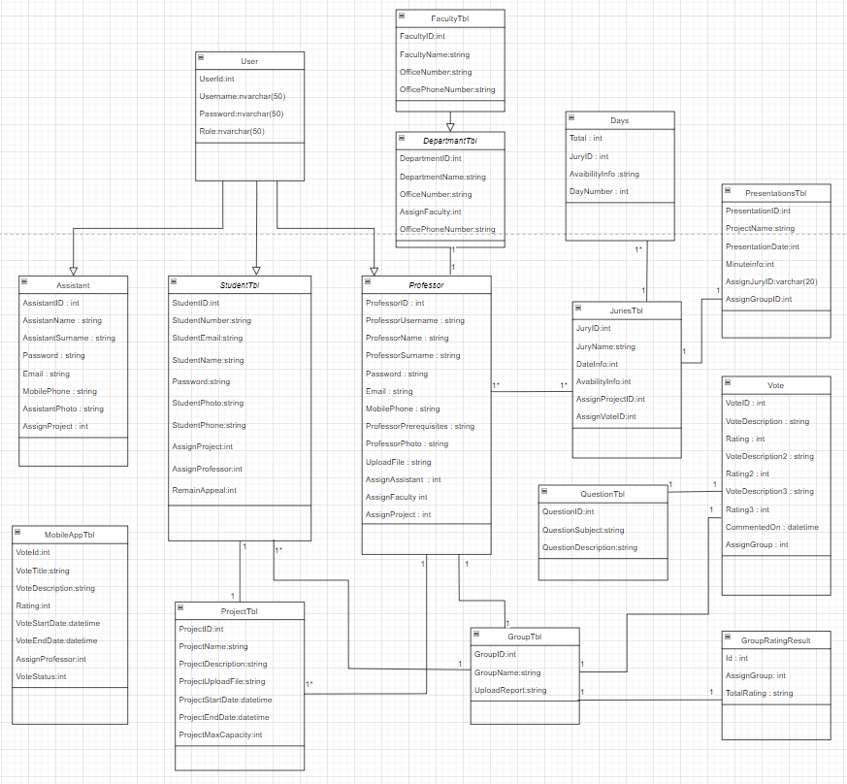

## ACTIVITY DIAGRAM (WEB)

## 

## 

## 

## 

## 

## 

## 

## 

## 

## 

## 

## 

## 

## 

## 

## 

## 

## 

## 

## 

**ACTIVITY DIAGRAM (MOBILE)**

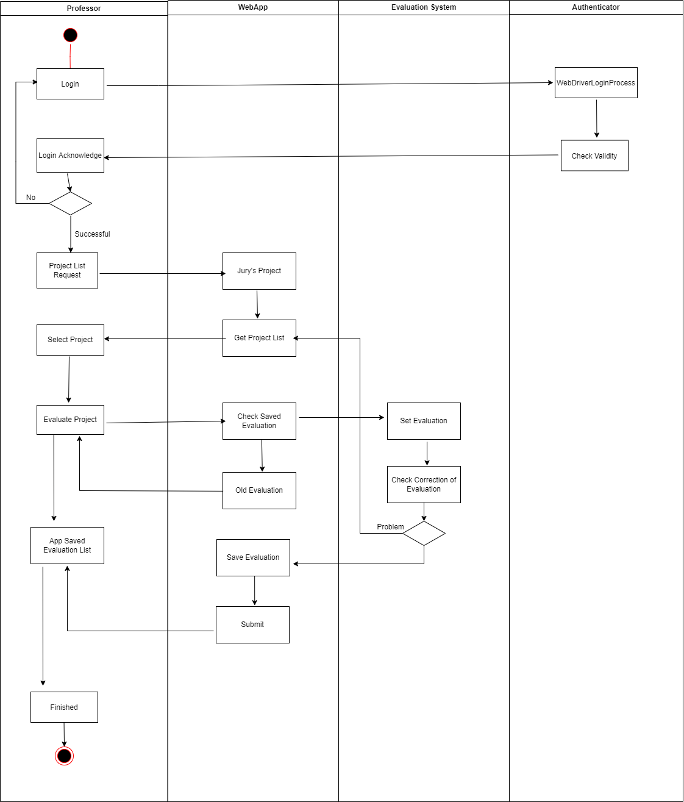

## Deployment View

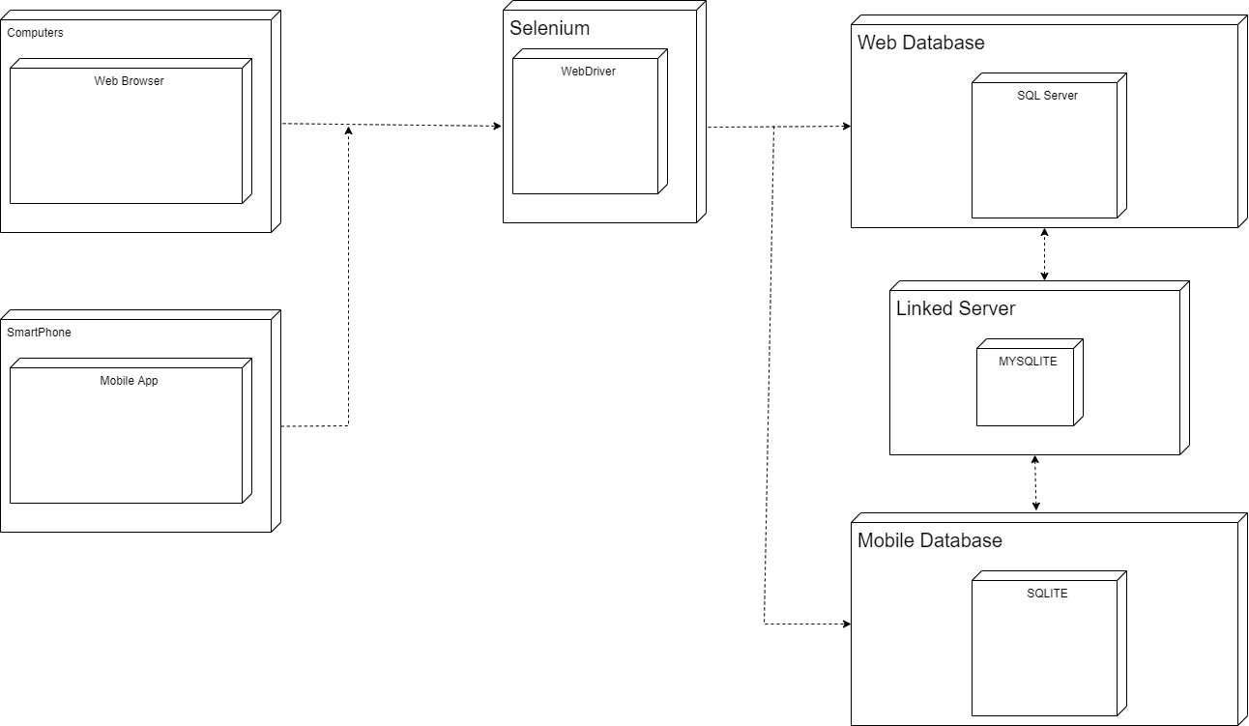

## 

## 

## 

## 

## 

## Use Case View

***Use Case View (WEB)***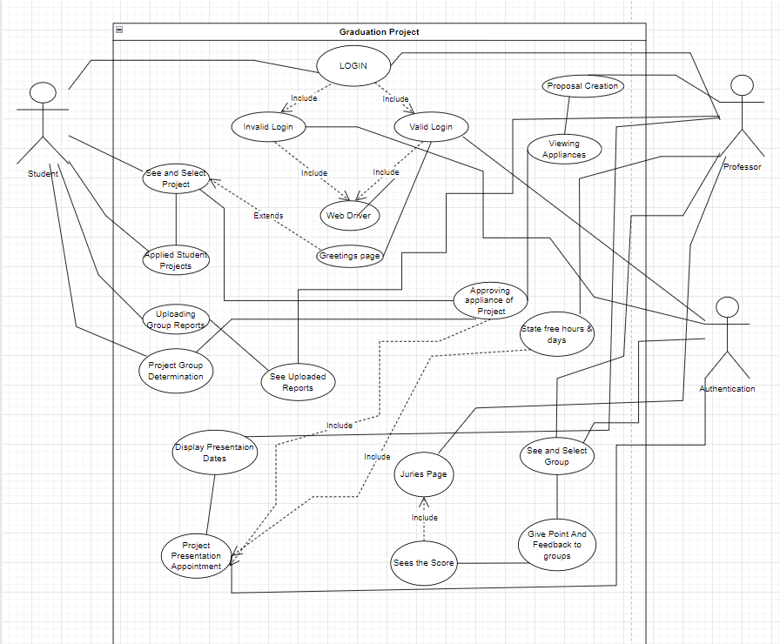

***Use Case View (MOBILE)***

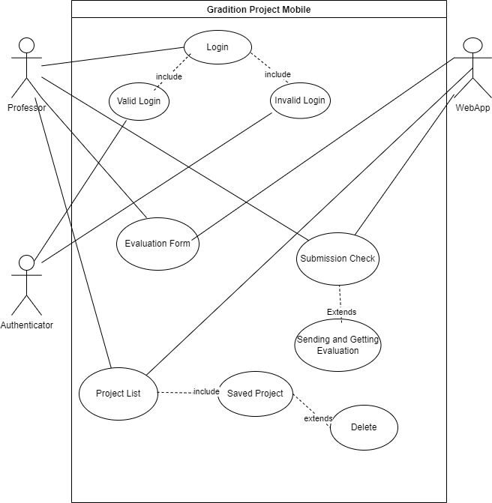

### Use Case Scenarios

# Design and Implementation

***LOGIN***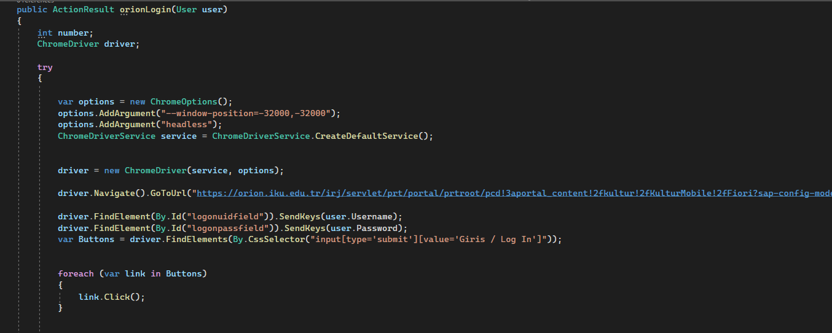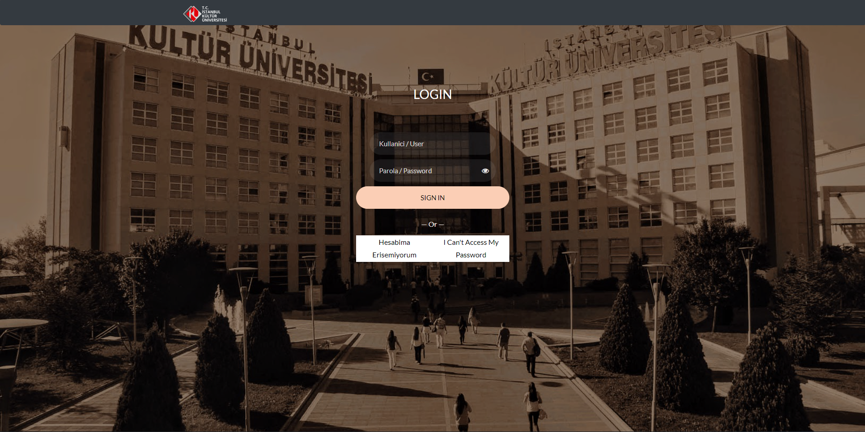

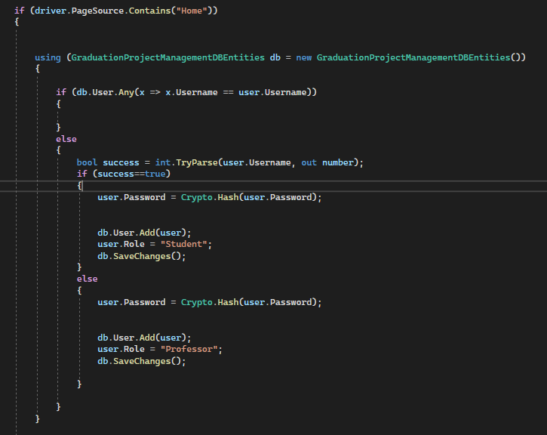

**Authorization**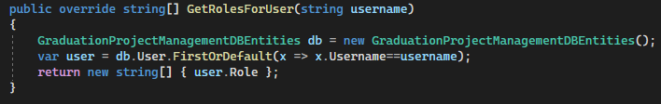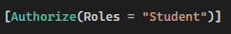

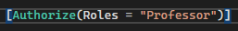

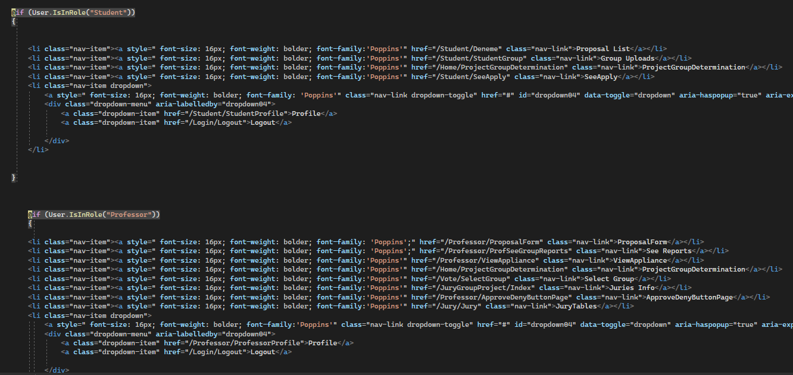

**Student Profile**

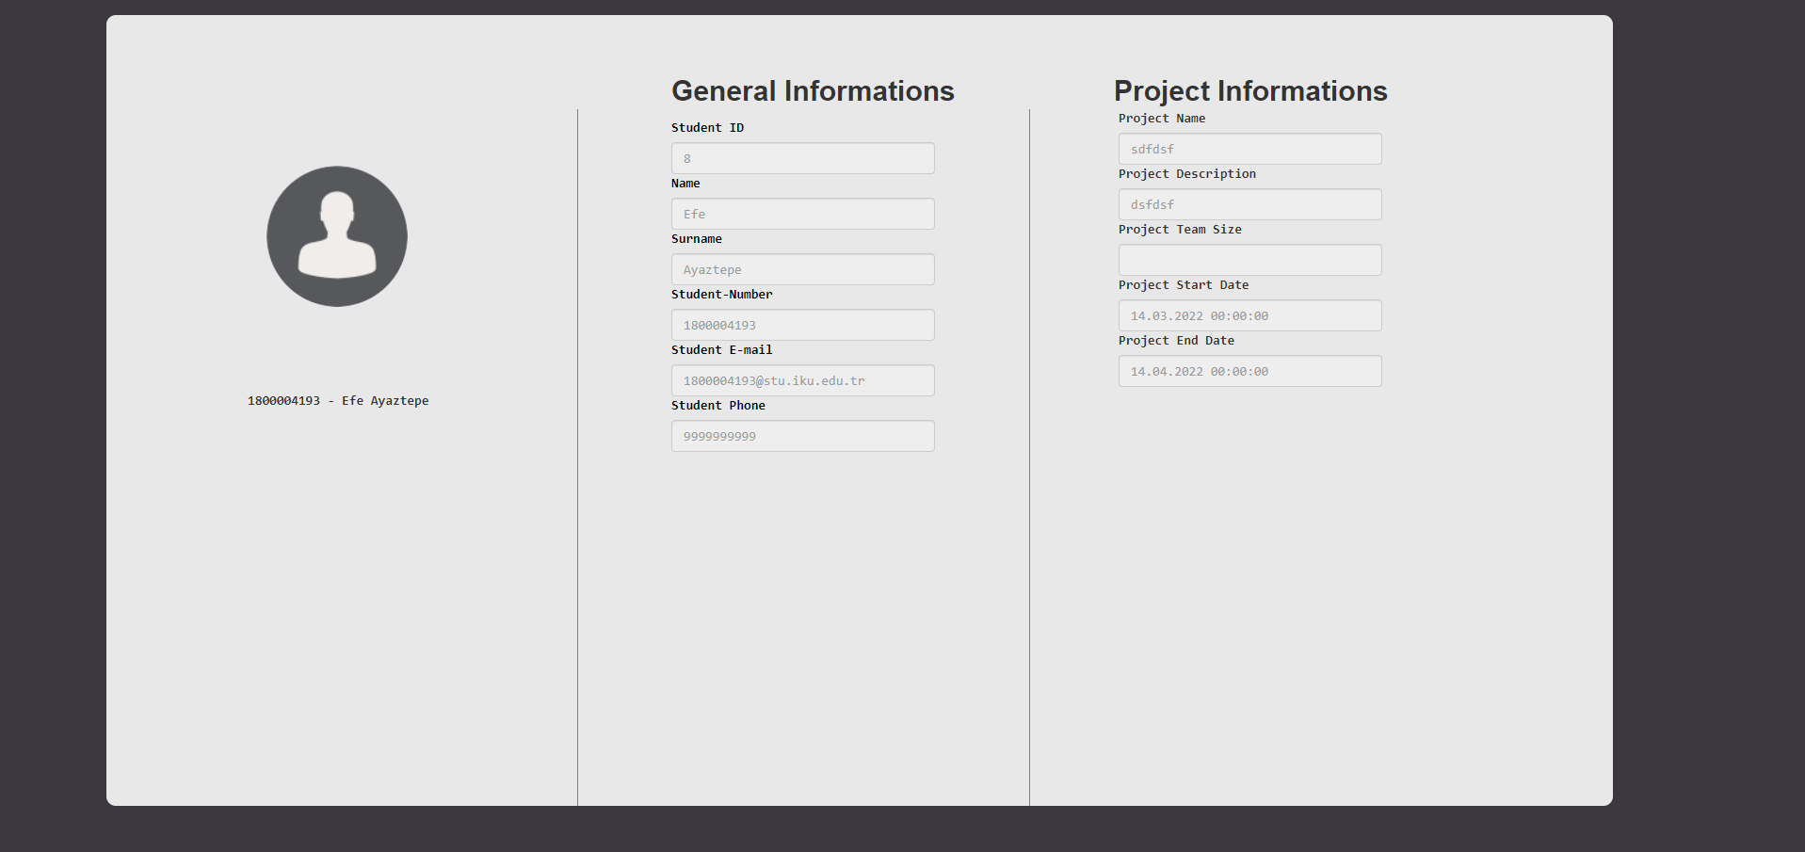

***Professor Profile***

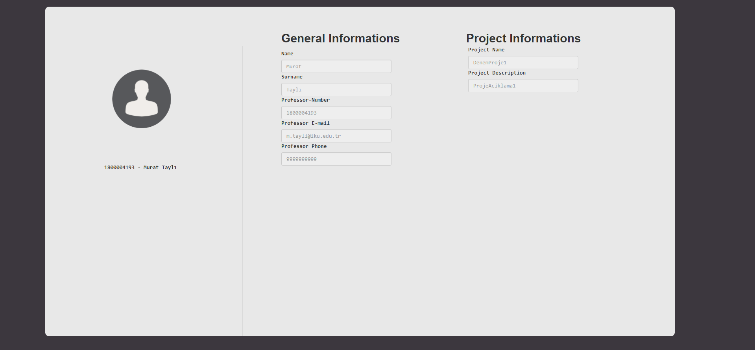

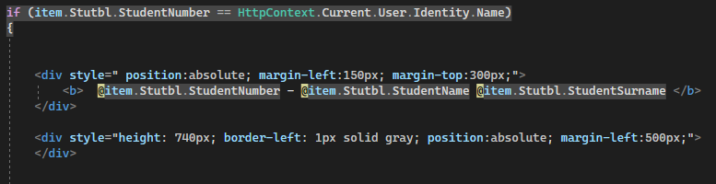

**Proposal List**

**Proposal List**

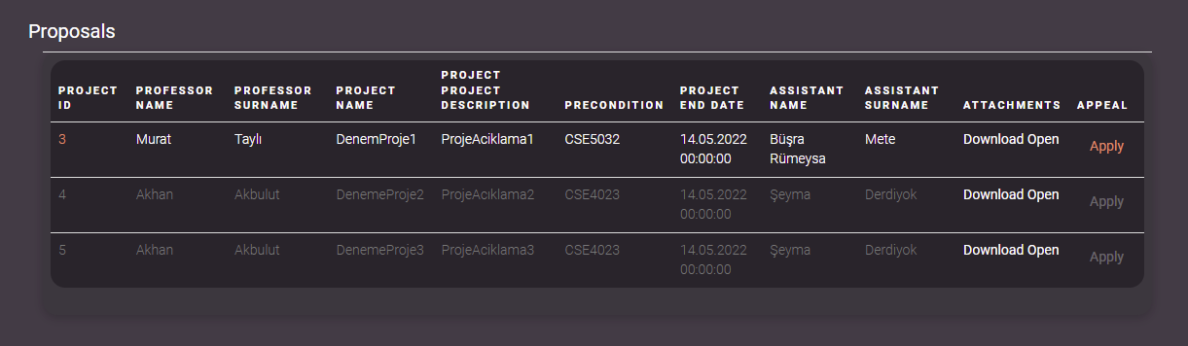

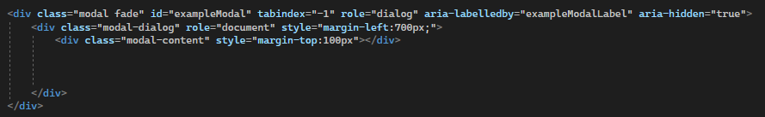

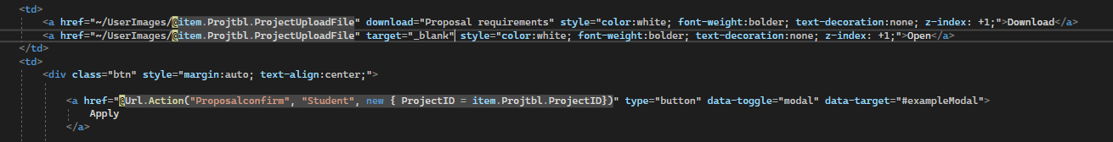

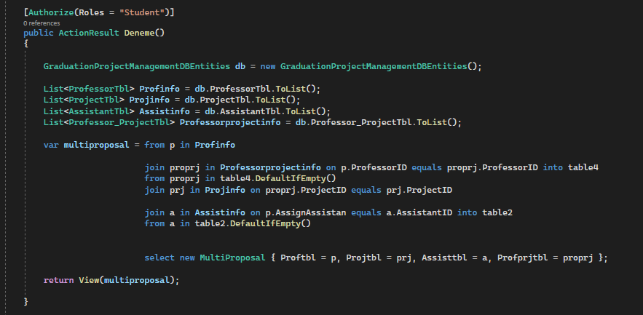

**Proposal Confirm**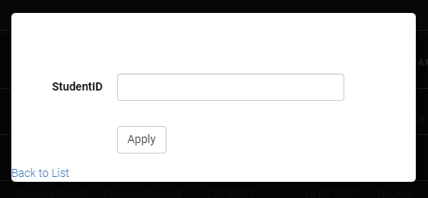

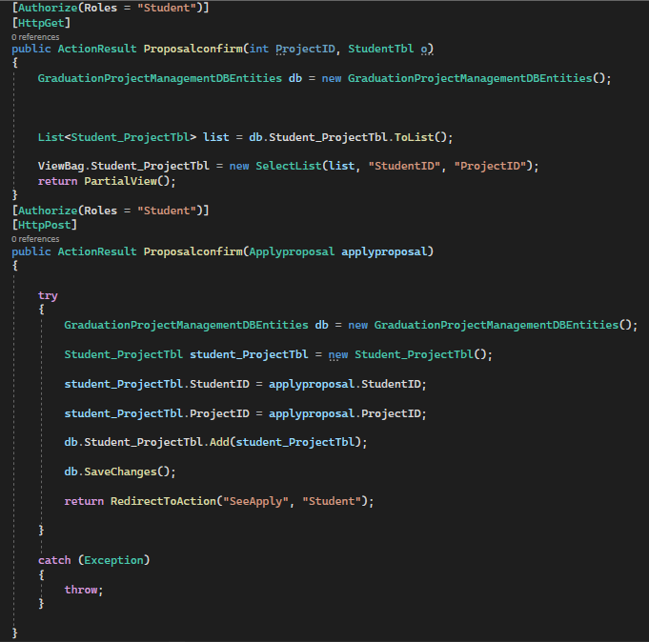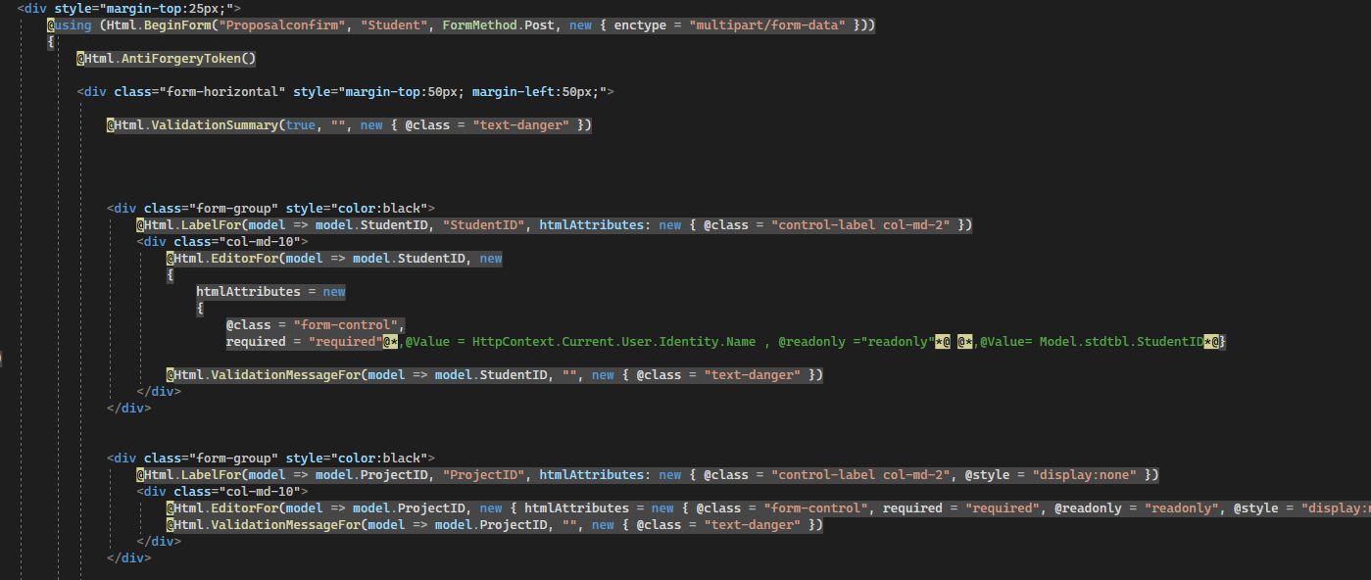

**Student Groups**

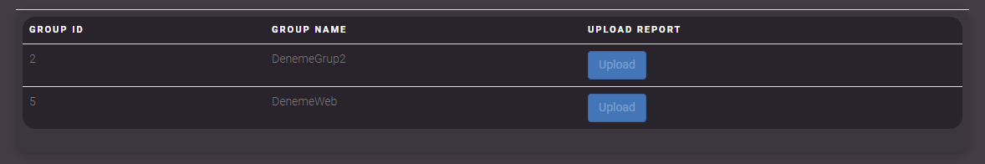

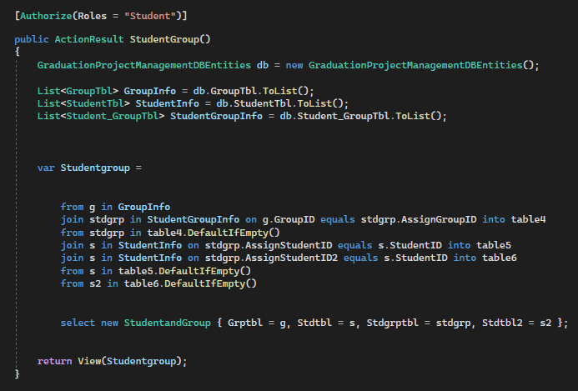

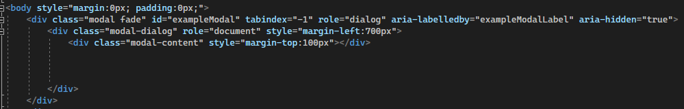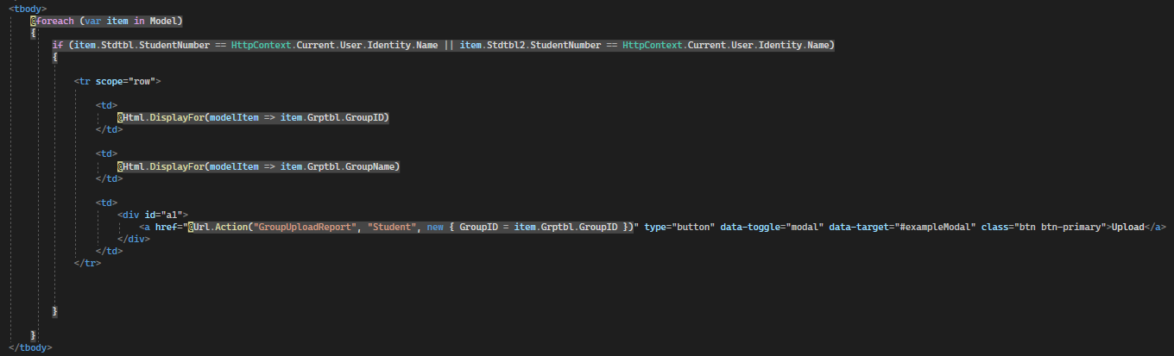

**Upload Group Report**

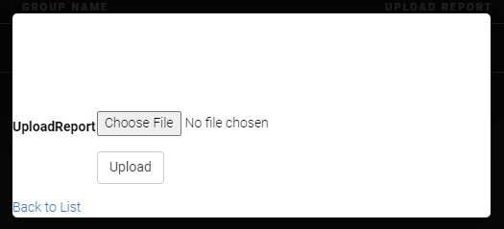

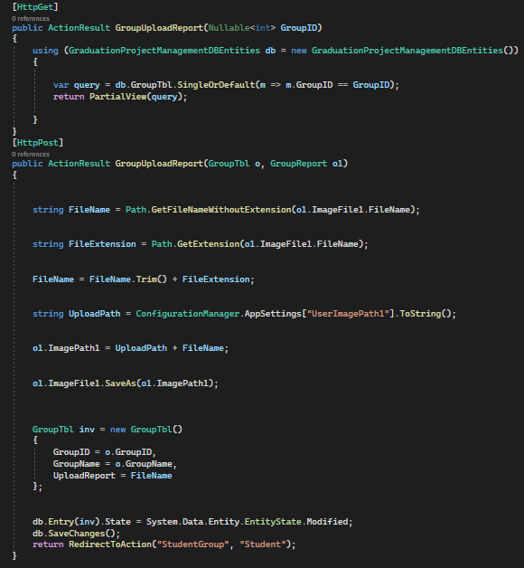

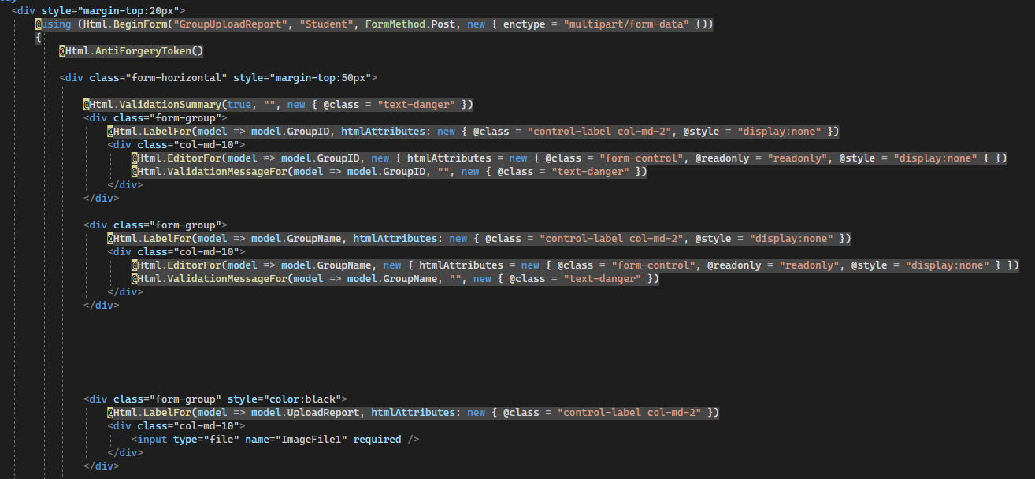

**See Apply**

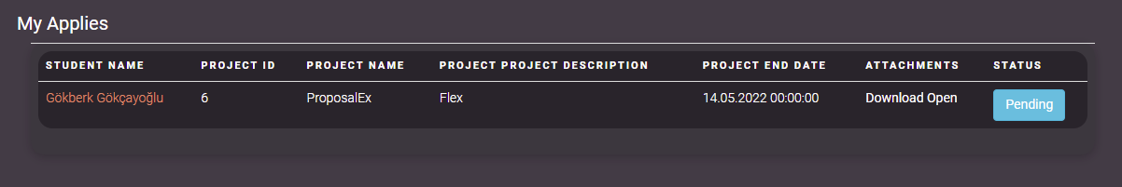

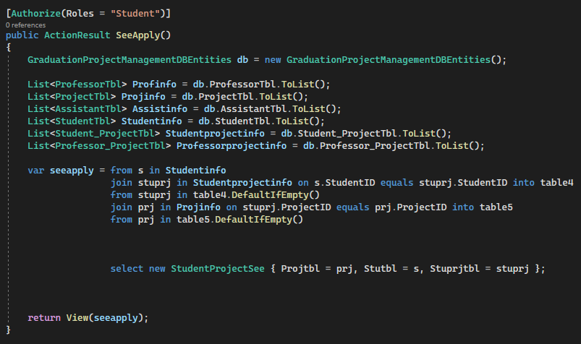

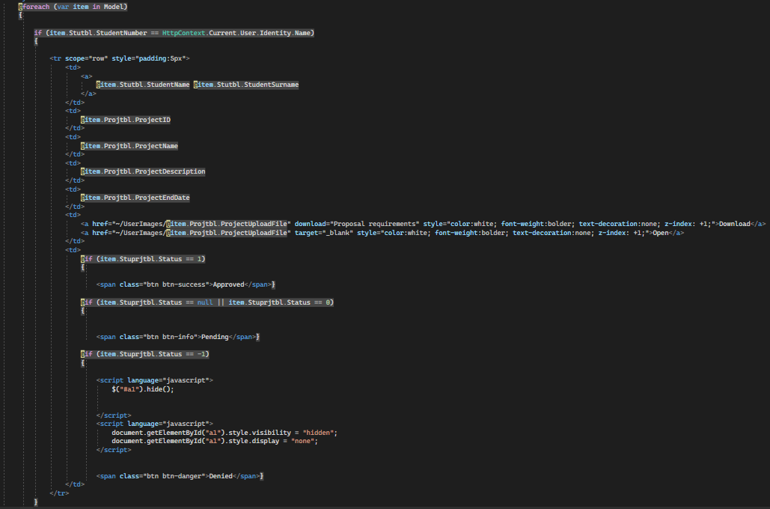

**Display Group Report Upload (Professor Side)**

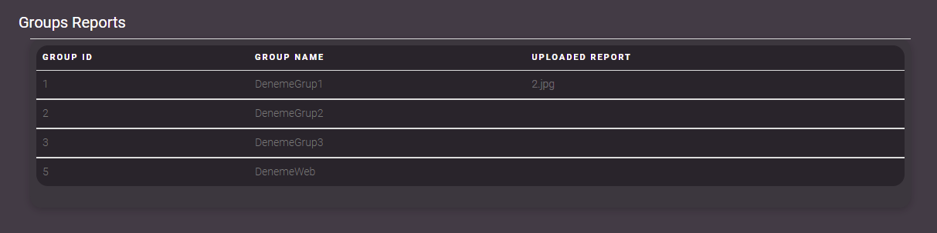

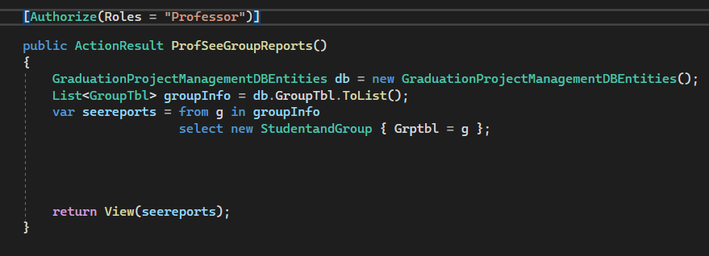

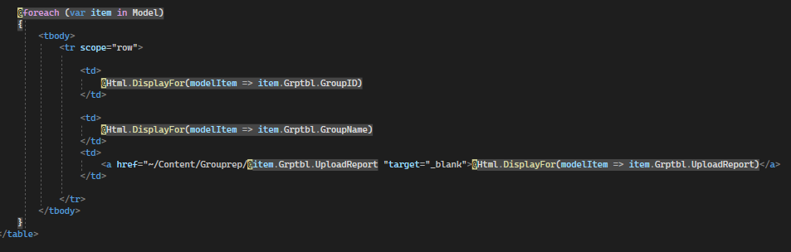

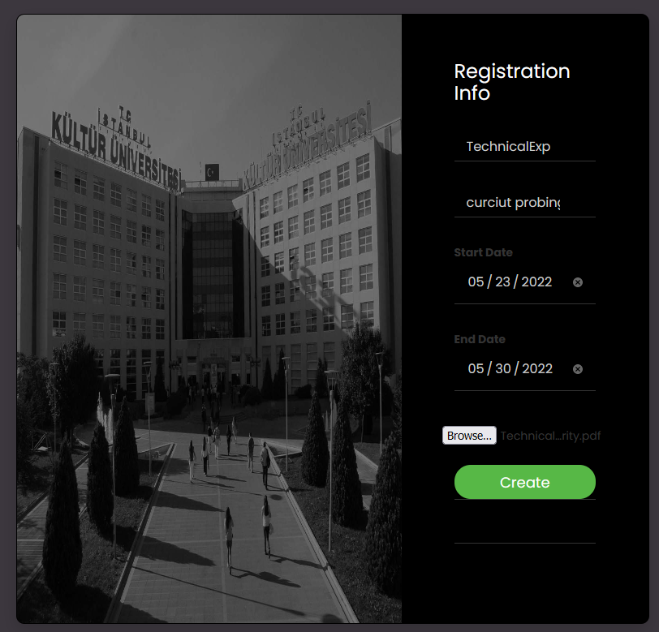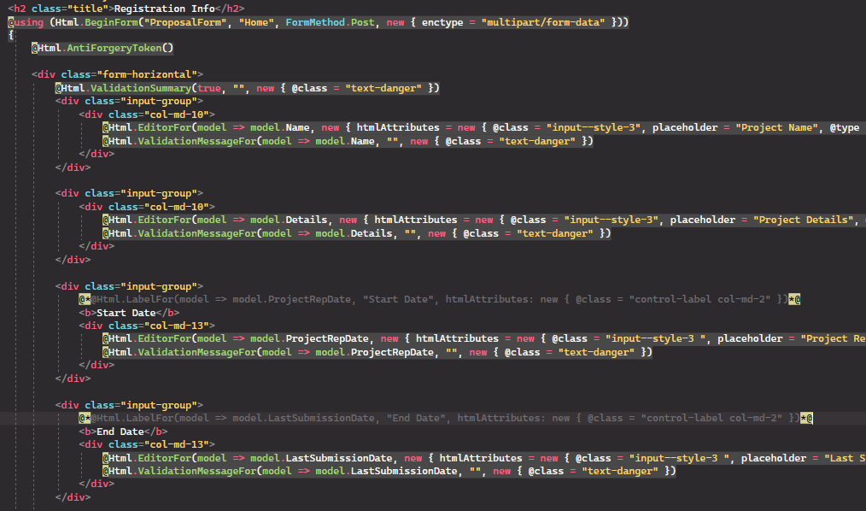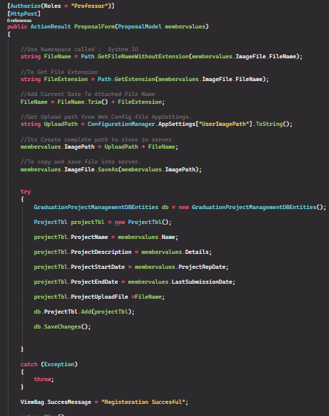**Proposal Form (Professor Side)**

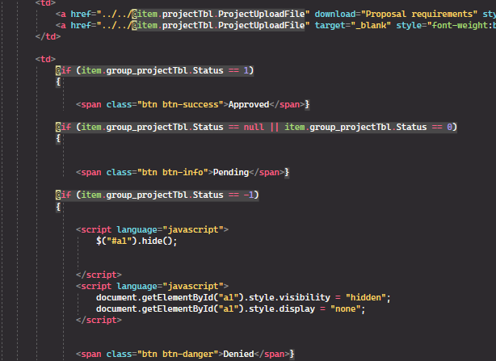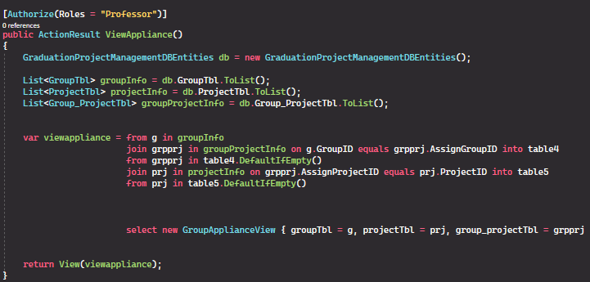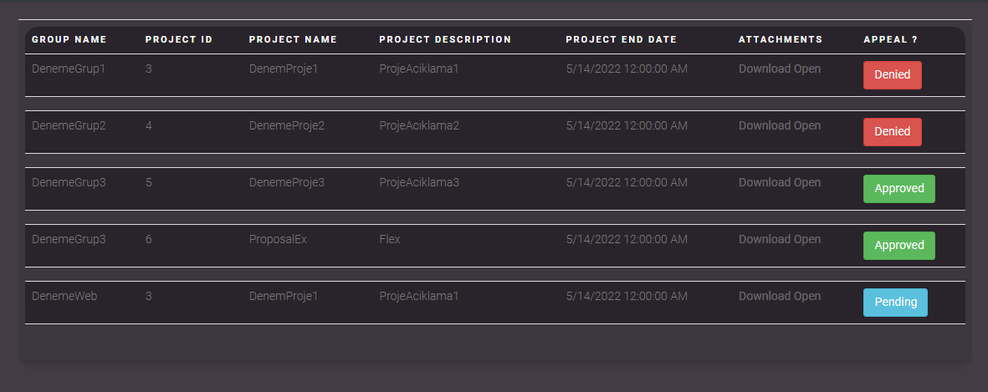**View Appliance (Professor Side)**

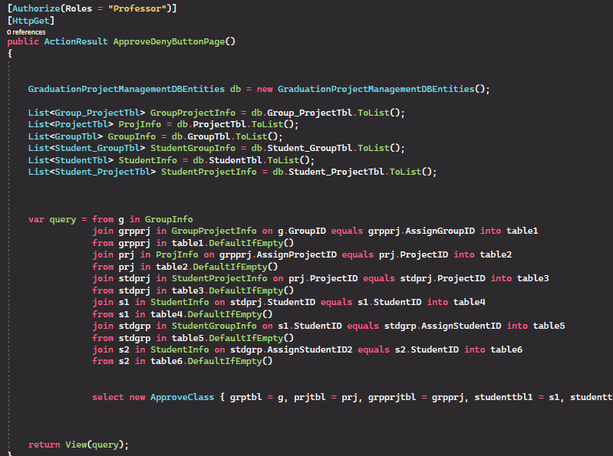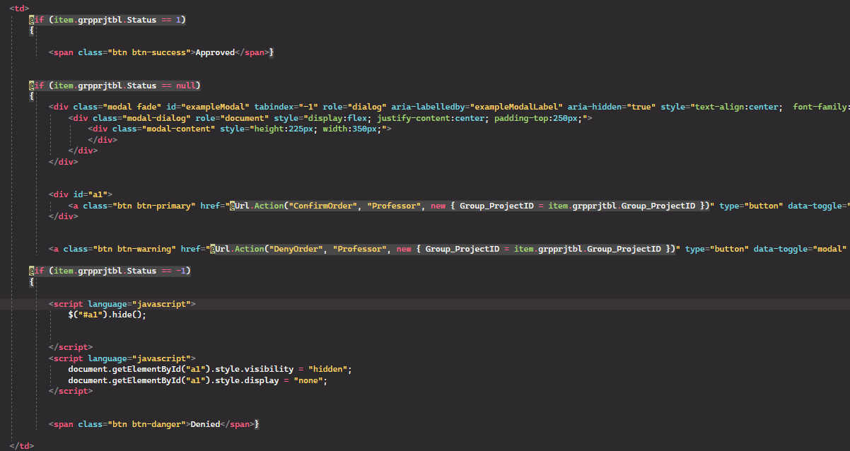**Approve Deny Button Page (Professor Side)**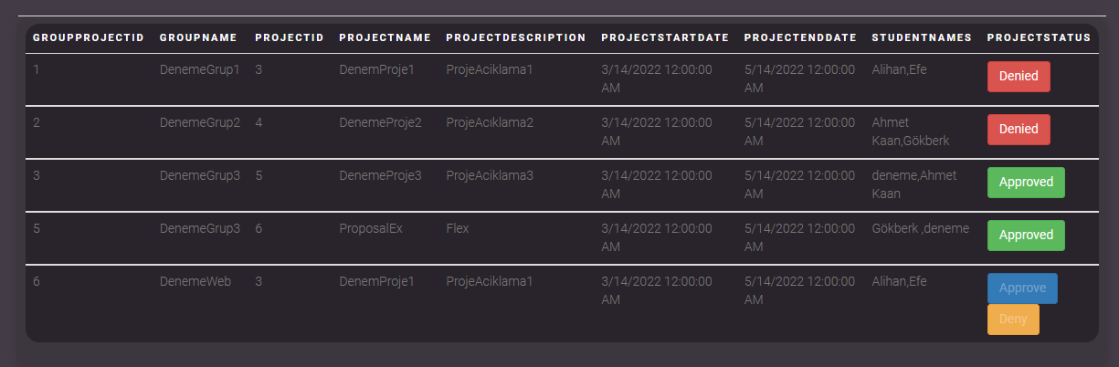

**Project Group Determination (Student Side)**

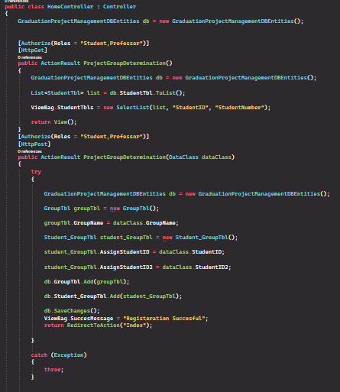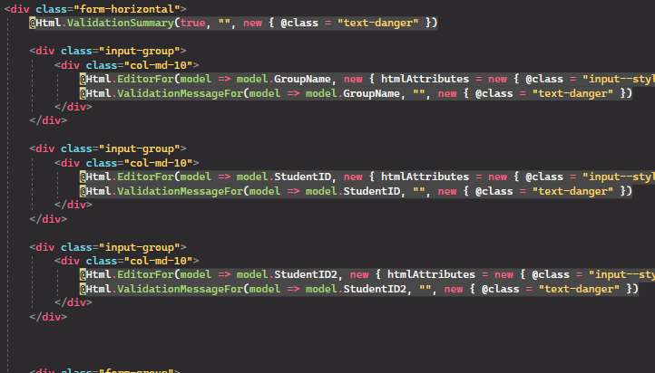

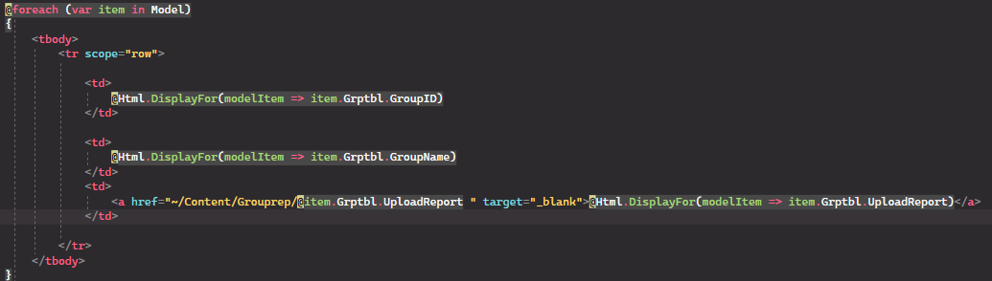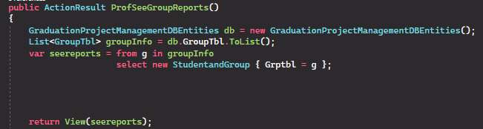**ProfSeeGroupReports (Professor Side)**

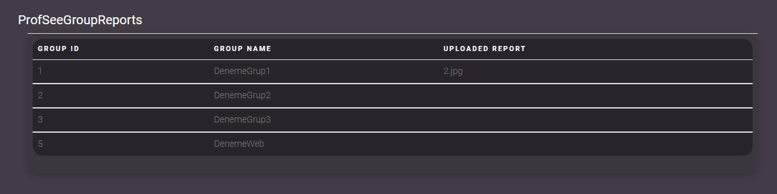

**Calendar / Availability (Jury Side)**

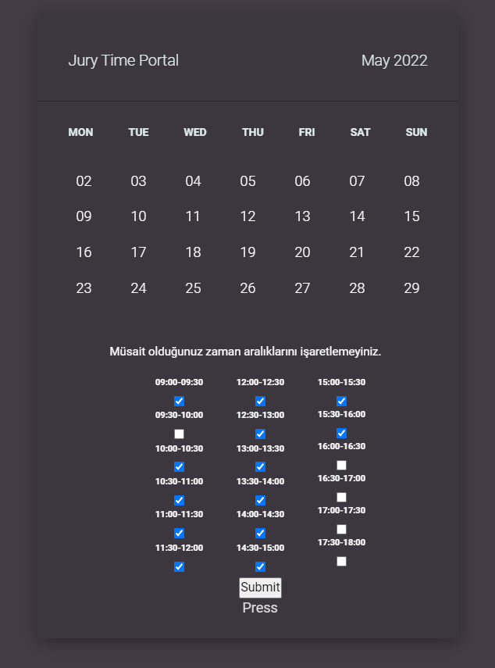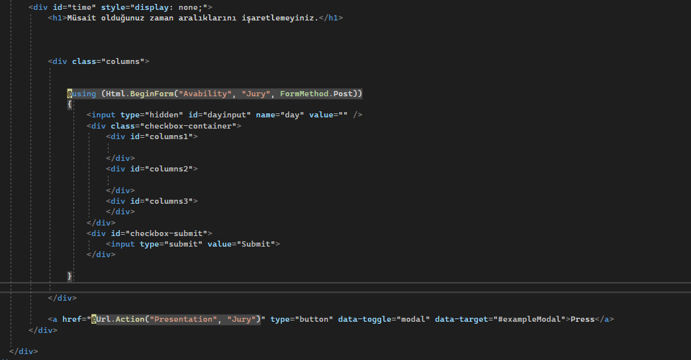

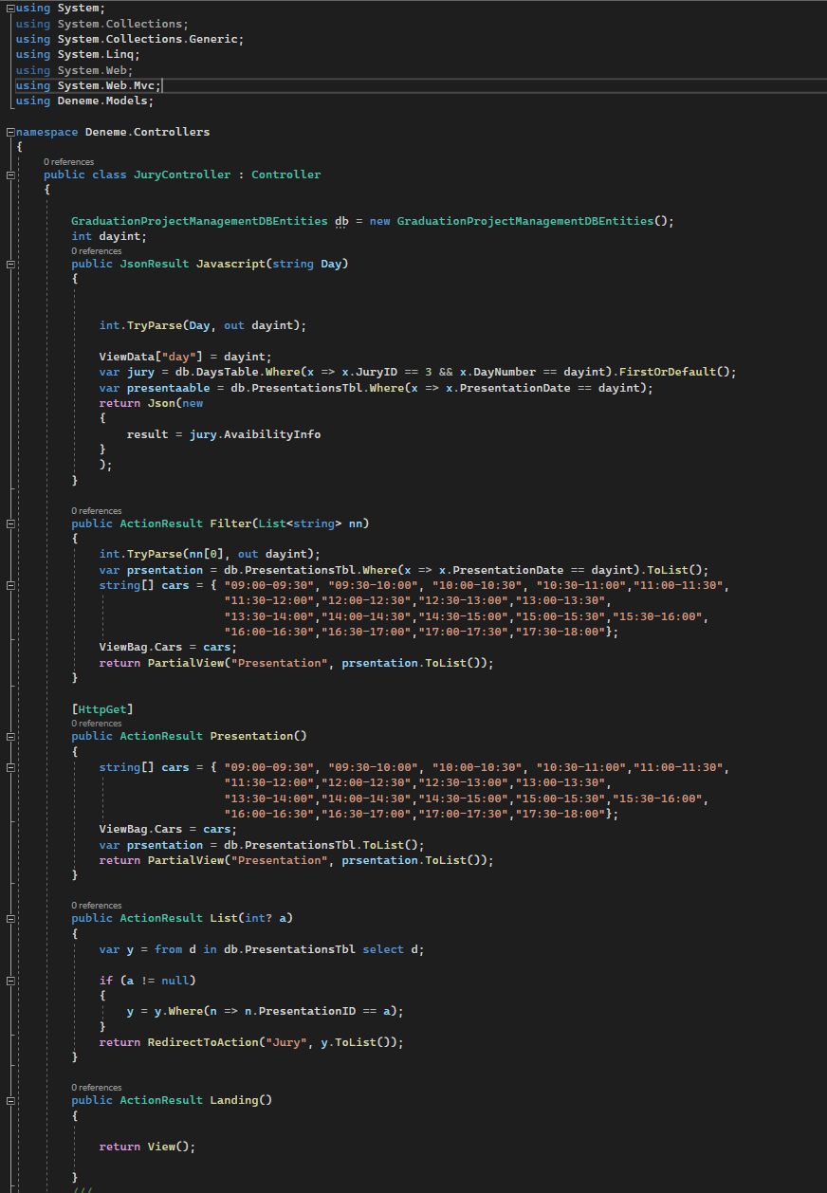 

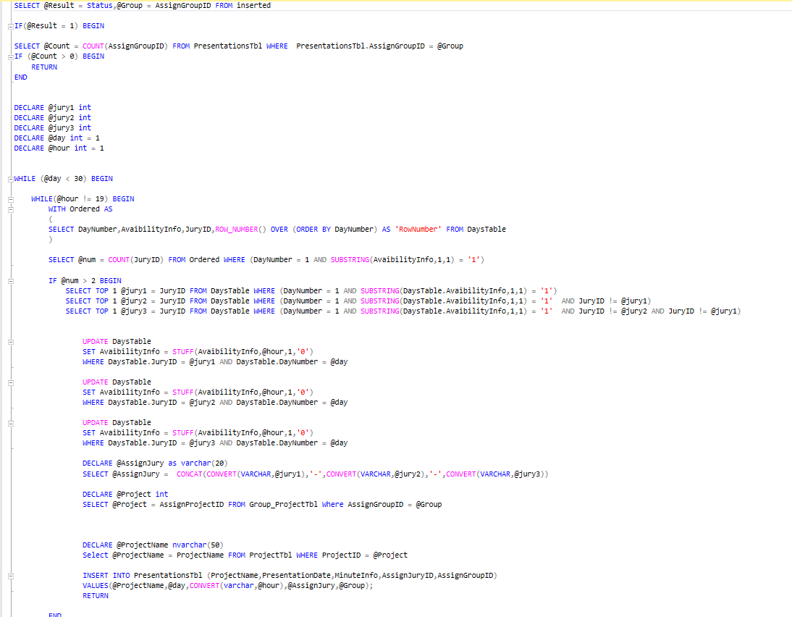

**Evaluation Page (Jury Side)**

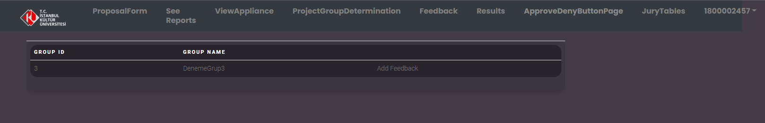**Selecting Group**

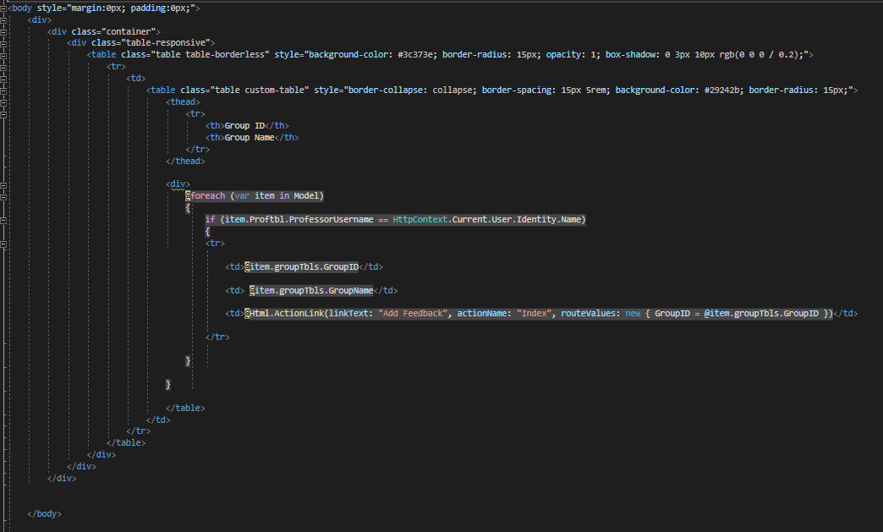

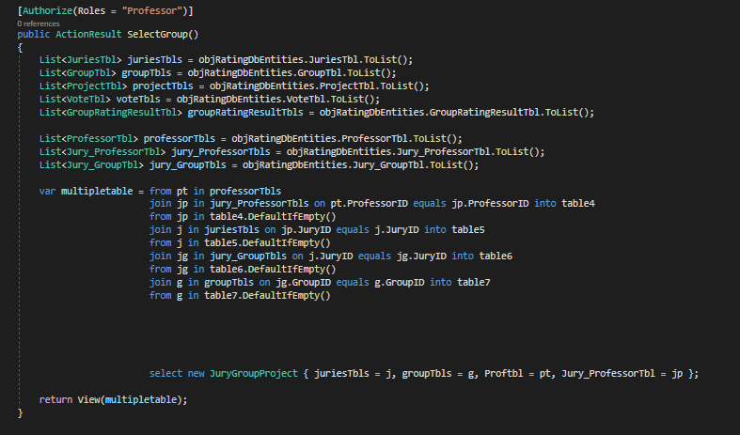

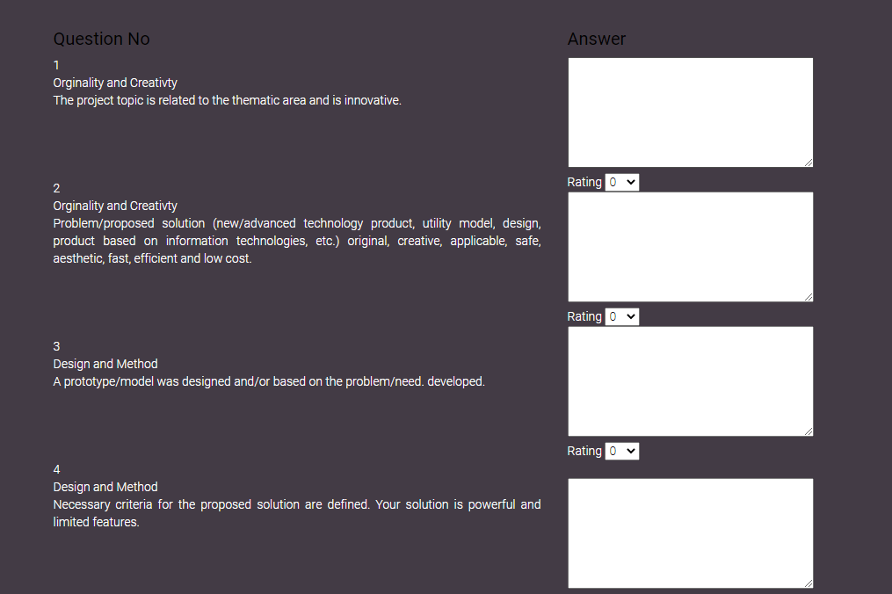**Evaluation Page (Jury Side)**

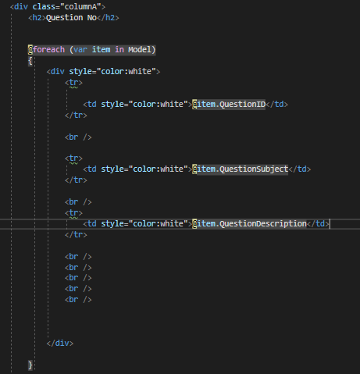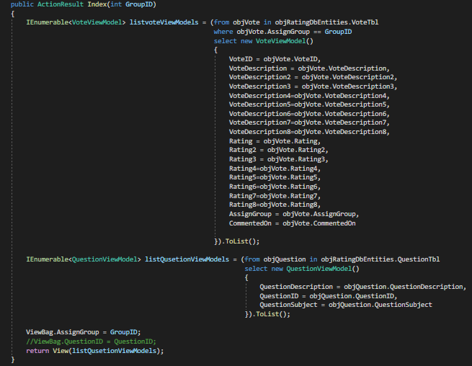

**Evaluated Group Page (Jury Side)**

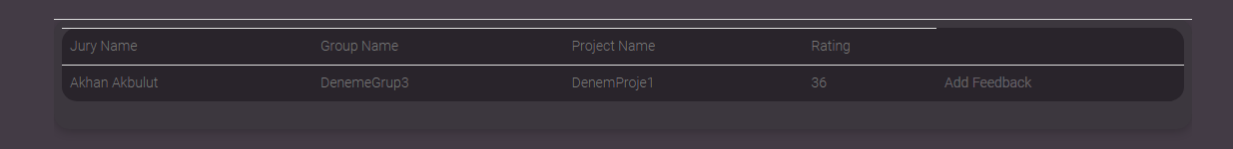

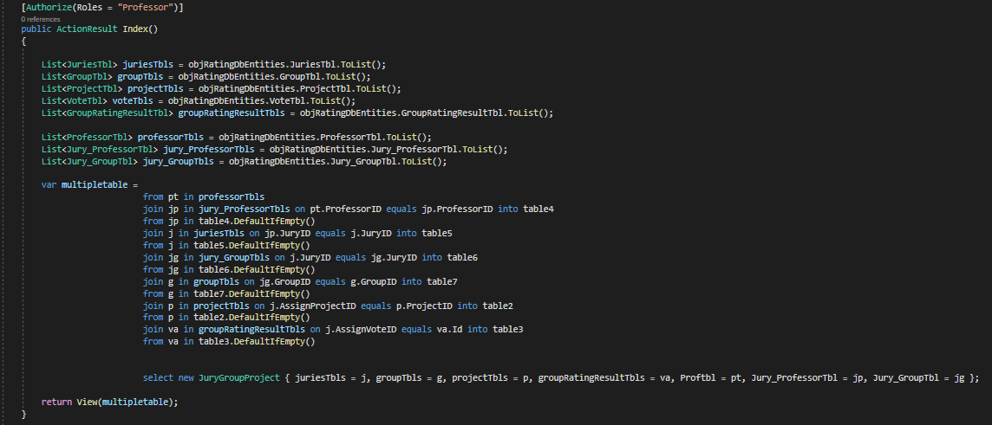

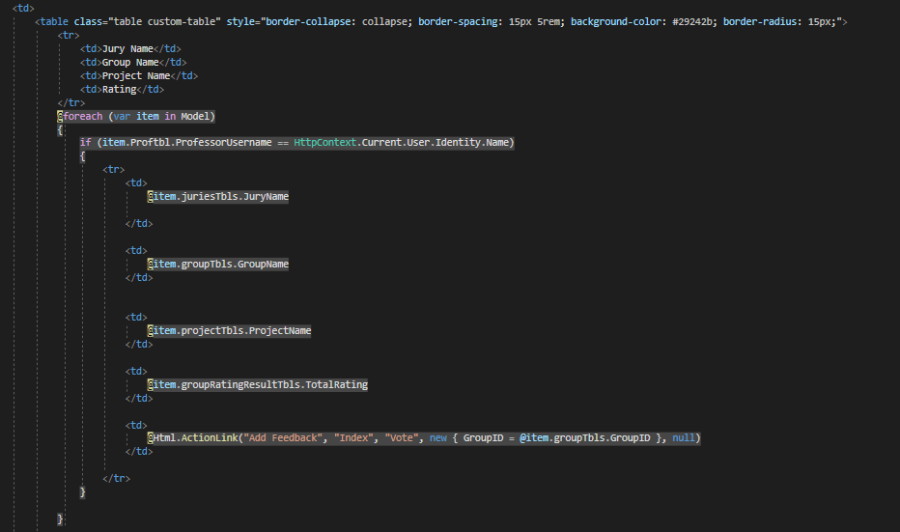

**Evaluated Group Page (Jury Side)**

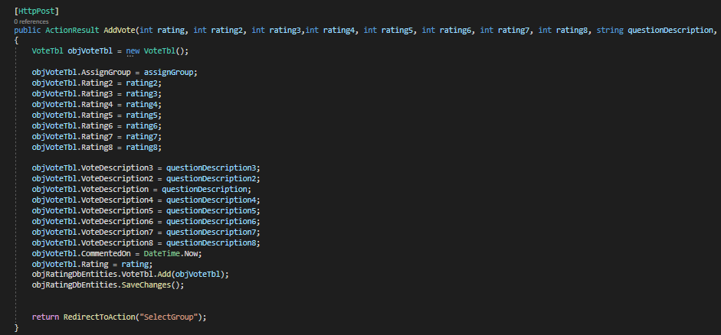

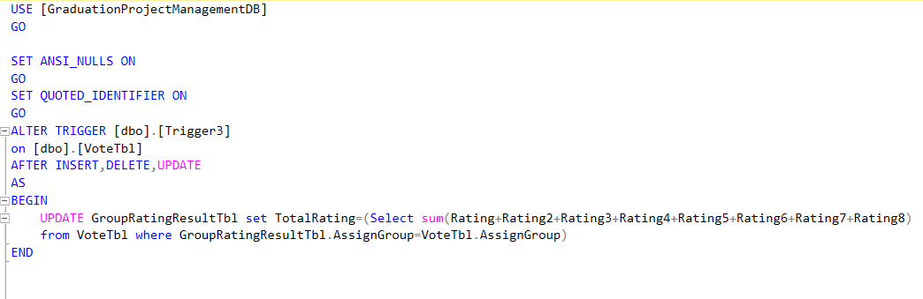

**Mobile App**

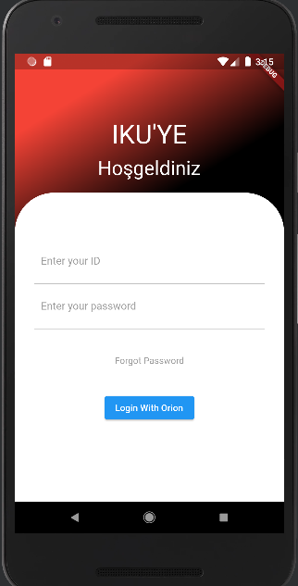

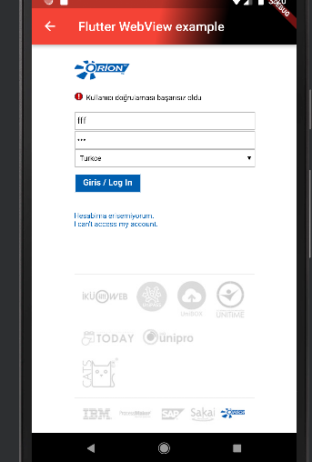

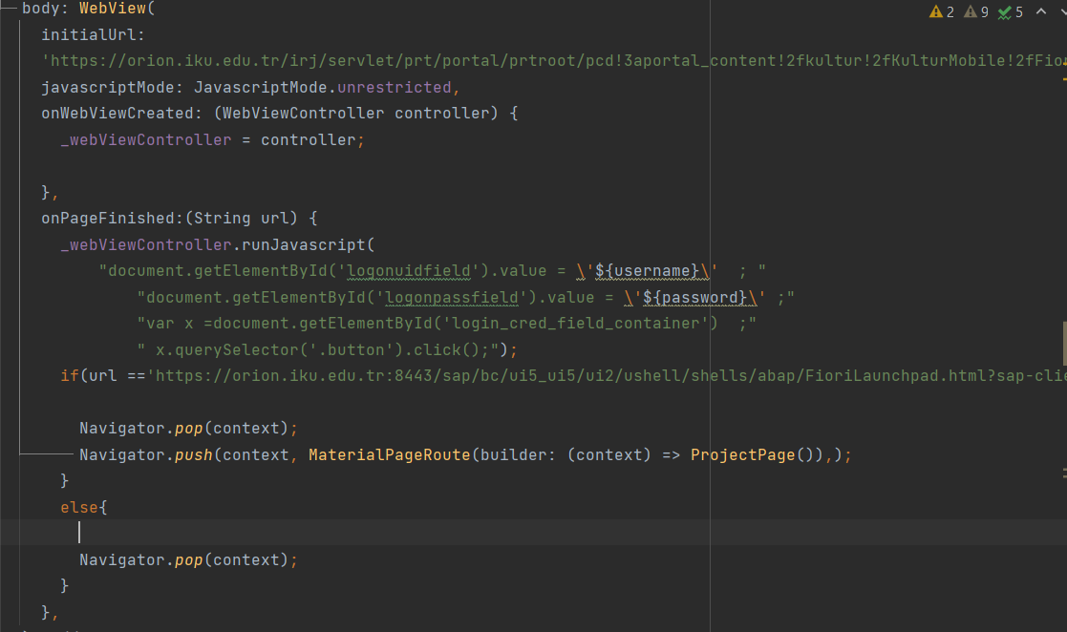

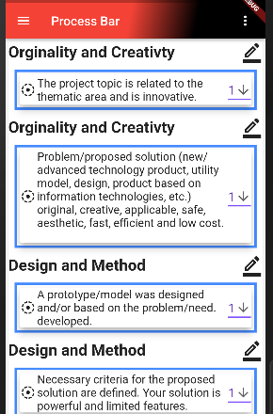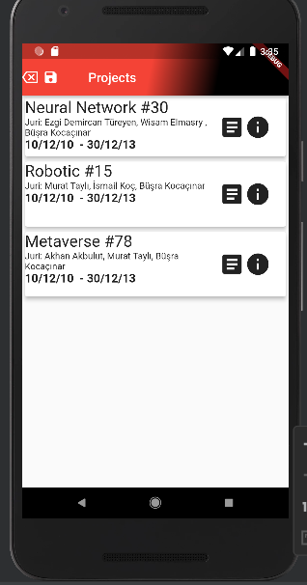

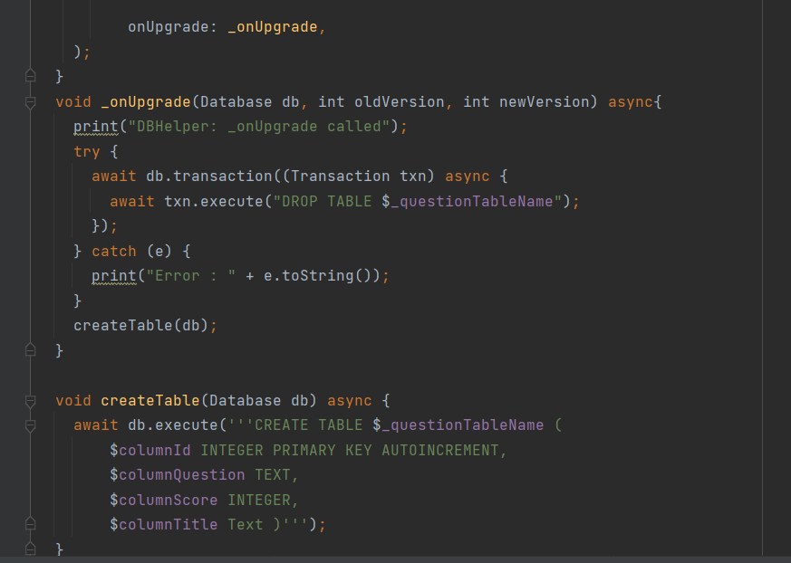

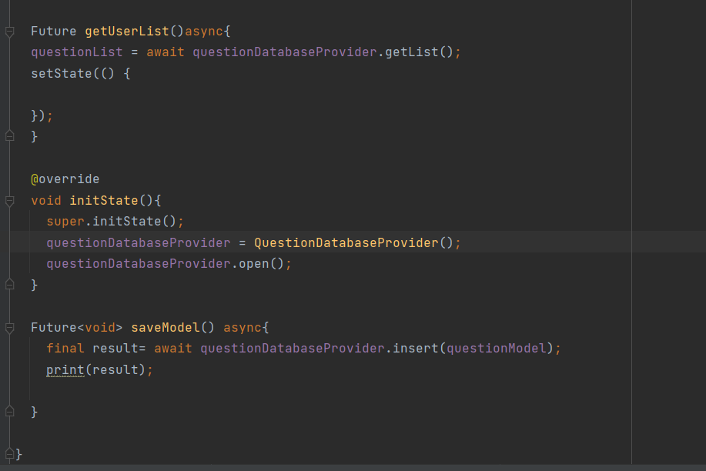

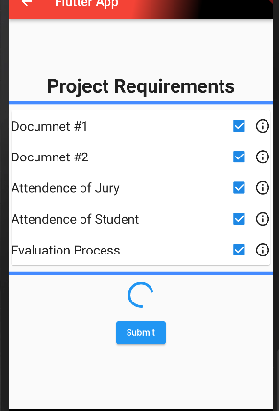

# Other Supporting Information

*< They may include:*

*(a) Sample I/O formats, descriptions of cost analysis studies, results of user surveys*

*(b) Supporting or background information that can help the readers of the SRS*

*(c) A description of the problems to be solved by the software*

*(d) Special packaging instructions for the code and the media to meet security, export, initial loading, or other requirements*

*….>*

# References

*< Identify each document by title, report number - if applicable - date, and publishing organization.*

*Specify the sources from which the references can be obtained.>*

Our CSS references that we have used to implement to our codes.

<https://colorlib.com/wp/template/table-05/>

<https://colorlib.com/wp/template/css-table-15/>

<https://colorlib.com/wp/template/colorlib-regform-3/>

<https://colorlib.com/wp/template/contact-form-v4/>

<https://colorlib.com/wp/template/contact-form-v3/>

<https://colorlib.com/wp/template/login-form-20/>

<https://www.c-sharpcorner.com/UploadFile/cd7c2e/open-a-new-web-form-in-the-model-popup-of-Asp-Net-applicatio/>